

Smoking Cessation Support Platform

Documentation

Member:

Full name | ID
Khúc Ngọc Sơn | SE184040
Cao Hữu trí | SE184047
Nguyễn Văn Dũng | SE184094
Trương Hoàng Quí | SE184355
Lê Thị Trà Mi | SE184379

FUHCM, SUMMER 2025

TABLE OF CONTENTS

1 Introduction 3
1.1 Overview 3
1.2 Scope 3
1.3 References 3
2 Project scope 4
3 Scrum Process 5
4 FUNCTIONAL Requirements 6
4.1 Roles 6
4.2 Use Cases Diagram 7
5 NON-FUNCTIONAL Requirements 8
5.1 Usability 8
5.2 Reliability 8
5.3 Performance 8
5.4 Security 8
5.5 Scalability 8
5.6 Maintainability 9
6 Screen Flow 10
7 database design 11
7.1 [ERD] 11
7.2 [Database diagram] 11
8 source control 12

Introduction

Overview
The Smoking Cessation Support Platform is a web-based system designed to assist individuals in quitting smoking through professional consultation, community support, achievement tracking, and self-management tools. The platform provides features such as consultation booking, progress monitoring, achievement badges, community discussions, resource sharing, and secure online payments.

Scope
This platform targets individuals seeking to quit smoking, healthcare professionals, and system administrators. It provides functionalities for user registration and profile management, scheduling and managing consultation sessions, receiving reminders and notifications, participating in community discussions, sharing resources, and making secure online payments for services.

References
Use Case Diagram:
Source Control:

Project scope
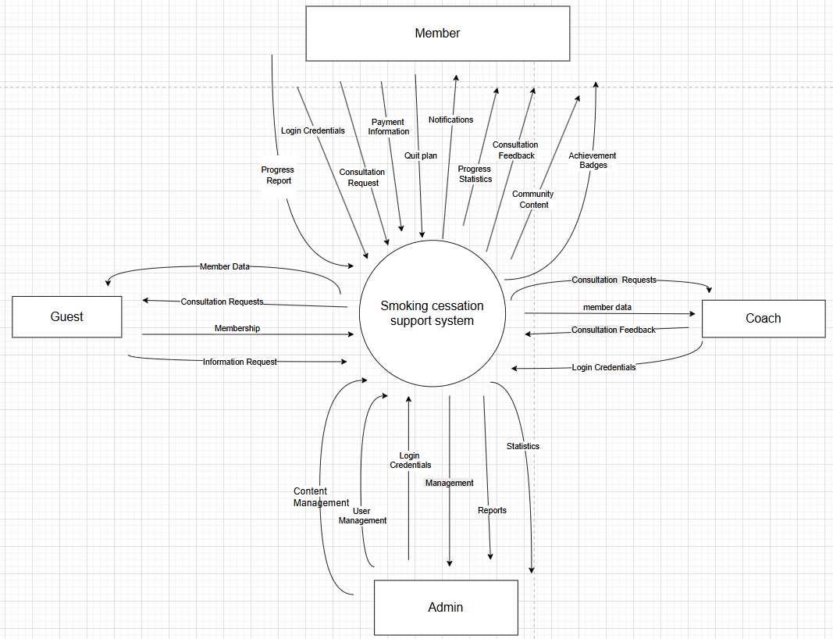
Fig-1. Context Diagram for Smoking Cesation Support Platform

- Members: Register, manage profiles, schedule consultations, receive notifications, track progress, join communities, purchase packages, and make payments.
- Coaches: View assigned members, manage consultations, provide feedback, and track member progress.
- Admins: Manage users, content, reports, statistics, system configuration, and handle violations.
- Guests: Can view public content, request information, and register as members.

Scrum Process
The project is a software development practice, so our team applies Scrum in a simple way, suitable for the group's size and experience:
Team structure:
- Product Owner: Provides requirements and feedback.
- Scrum Master (also a team member): Reminds about progress and supports general issues.
- Other members: Divide and complete assigned tasks.
Working process:
- The project lasts 10 weeks, divided into 5 Sprints (2 weeks per Sprint).
- At the beginning of each Sprint, the team meets online or in person to agree on tasks and objectives.
- Each member updates their progress and discusses difficulties in the group chat.
- At the end of each Sprint, the team reviews the results together, does a demo, receives feedback, and adjusts for the next Sprint.
Tools:
- Use Google Meet, Zalo/Facebook Messenger, and Github Project to manage tasks and track progress.

FUNCTIONAL Requirements

Roles
In the system, there are four main user roles, each with specific rights and functions:
- Admin:
  - Manage all user accounts (create, update, delete) and assign permissions.
  - Manage content: blogs, announcements, shared resources and review violation reports.
  - View reports and statistics on system usage and member progress.
  - Manage service packages and payments.

- Coach
  - View and manage assigned members.
  - Confirm and manage consultation schedules.
  - Track member progress and provide feedback after each session.
  - Update appropriate challenges for each assigned member.

- Member
  - Register and manage personal profile.
  - Set up and participate in implementing coach plans.
  - Track your personal progress (cigarettes per day, days smoke-free, money saved).
  - Participate in community discussions: post topics, share experiences, report inappropriate posts.
  - View and collect achievement badges.
  - Pay for packages.

- Guest
- View public information and articles about quitting smoking.
- Register for an account to access more features.
- Submit a request for information or advice.

Use Cases Diagram

Use case link: https://app.diagrams.net/#G1mSJKnjcEQ8V9HzvQ7umvcuF8kraAkwg7#%7B%22pageId%22%3A%22wuWER_XlBQ0hQIHaGWCE%22%7D
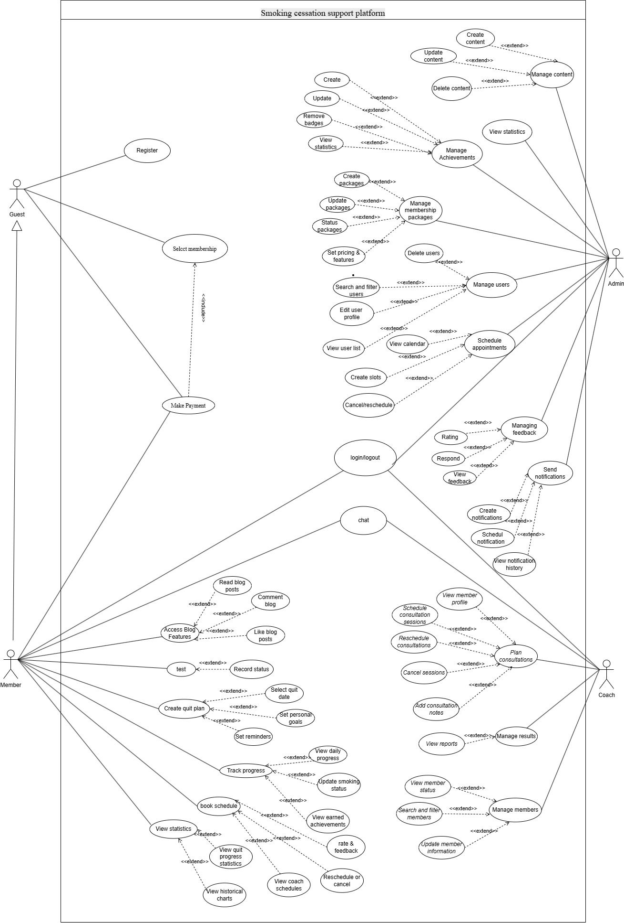
Fig 1- Use case diagram for Smoking Cessation Support Platform

NON-FUNCTIONAL Requirements

Usability
- The user interface shall be intuitive and easy to operate for all user groups.
- Features must be laid out logically, and all on-screen text shall be clear and unambiguous.

Reliability
- The system shall operate stably during demos, without any critical errors that interrupt the user experience.
- A manual backup mechanism must be in place to ensure no data is lost in the event of a failure.

Performance
- Response times for core functions (login, appointment booking, progress updates) shall be under 3 seconds.

Security
- Users’ personal data shall be stored securely and not disclosed to any third party.
- Account authentication must be enforced on login and before accessing any sensitive features.
- User passwords are encrypted using the BCrypt algorithm before being saved to the database, ensuring security and preventing password sniffing.

Scalability
- The system shall be designed with an extensible architecture to allow easy addition of new features or deployment to production servers in the future.

Maintainability
- Source code shall be organized clearly, following agreed naming conventions and folder structures to facilitate easy fixes and enhancements.

Screen Flow
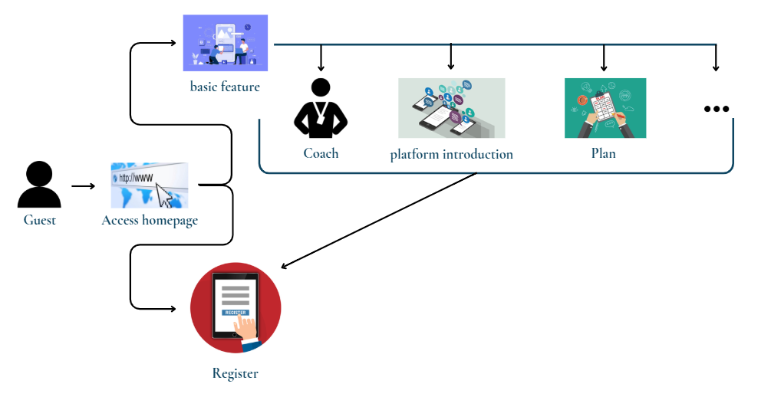
Fig-2: Screen flow for Guest

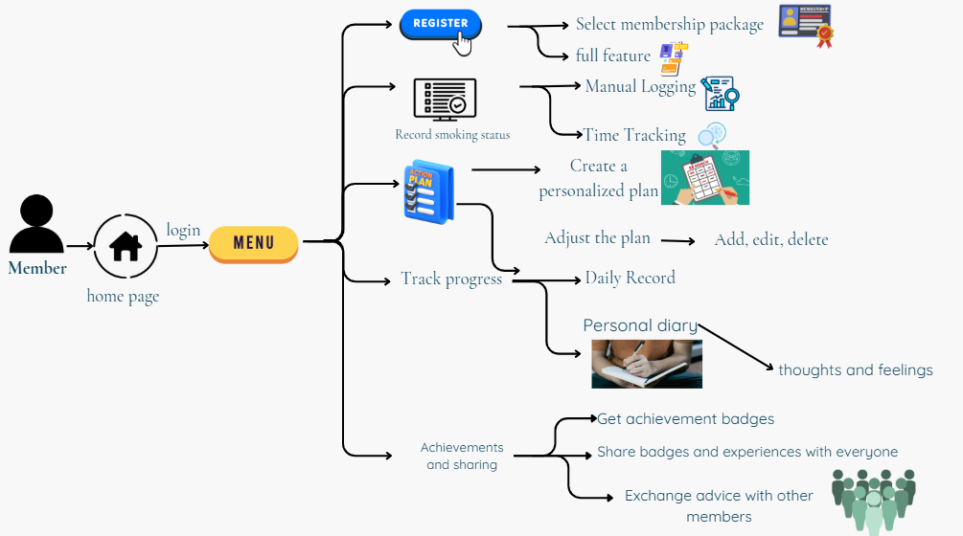
Fig-3: Screen flow for Member

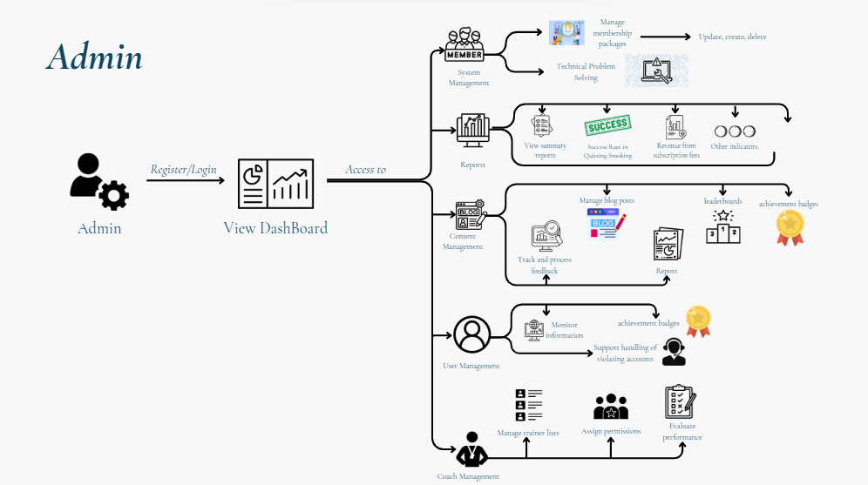
Fig – 4: Screen flow for Admin

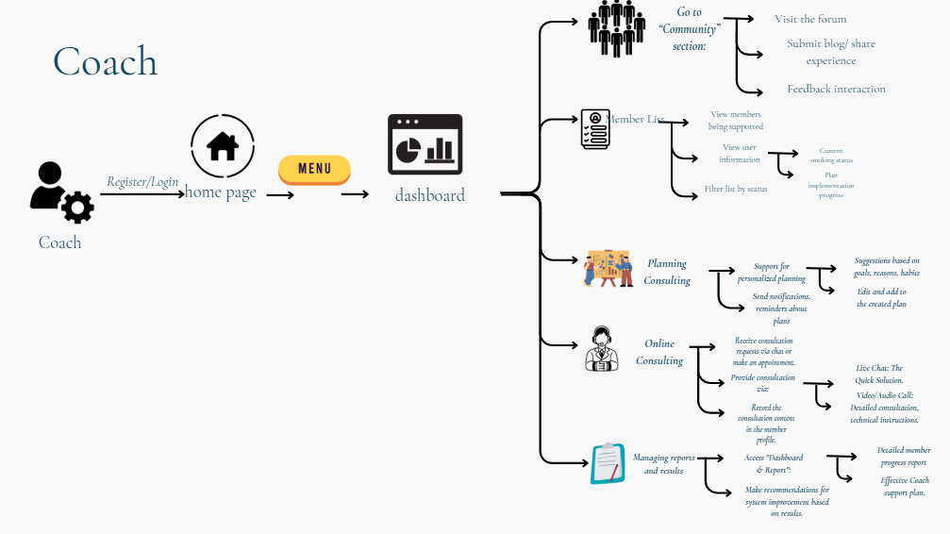
Fig – 5: Screen flow for Coach

Screen flow link: https://www.canva.com/design/DAGreSM0mL8/5P1-6E4b46hSXc4cQR_nCg/edit?utm_content=DAGreSM0mL8&utm_campaign=designshare&utm_medium=link2&utm_source=sharebutton

database design

[ERD]
https://app.diagrams.net/#G1mSJKnjcEQ8V9HzvQ7umvcuF8kraAkwg7#%7B%22pageId%22%3A%22wuWER_XlBQ0hQIHaGWCE%22%7D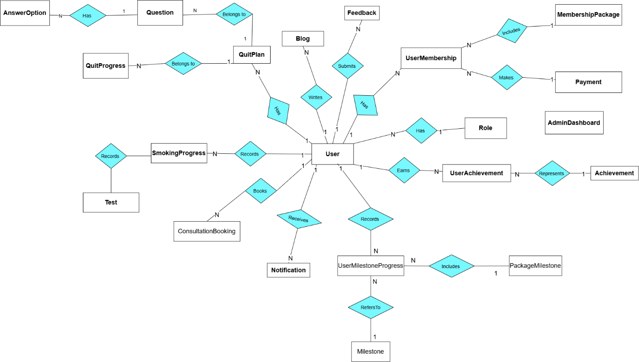
Fig – 6: Us for Smoking Cessation Support Platform

[Database diagram]
https://dbdiagram.io/d/Smoking-6833b369b9f7446da3176819
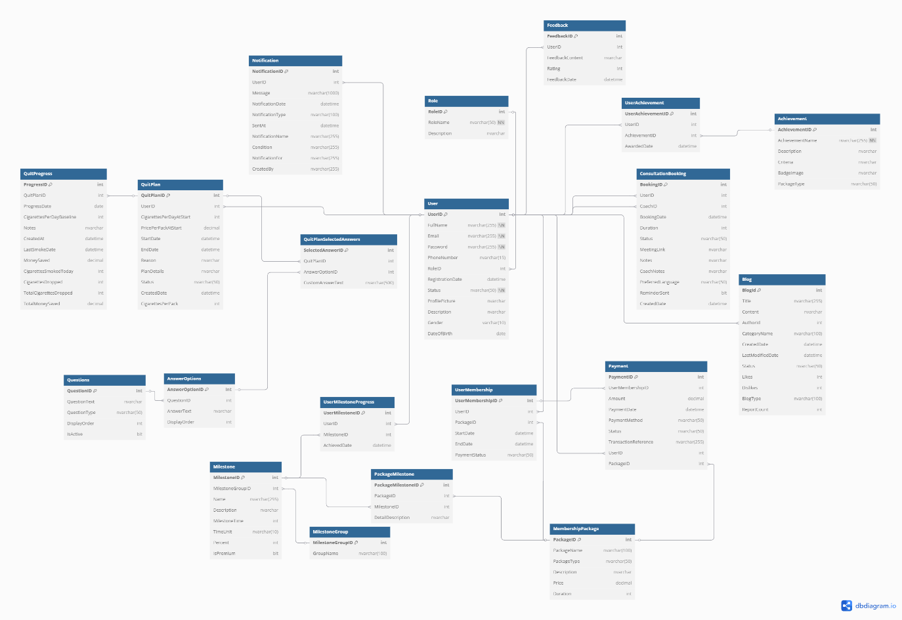
Fig – 7: Database diagram for Smoking Cessation Support Platform

source control
Github link: https://github.com/THQuis/SWP391_Group5

